DEEP OSCILLATION® - Generic Information for Clinician Websites

DEEP OSCILLATION® Links

About PhysioPod® http://www.physiopod.co.uk/about-us.shtml
Latest News http://www.physiopod.co.uk/articles.shtml
Product information http://www.physiopod.co.uk/products.shtml
Events http://www.physiopod.co.uk/Forthcoming- Events.shtml
Testimonials http://www.physiopod.co.uk/testimonials.shtml
Fields of Application http://www.physiopod.co.uk/fields-of- application.shtml
Clinical Effects http://www.physiopod.co.uk/clinical-effects.shtml
Practitioner List http://www.physiopod.co.uk/testimonials.shtml
Videos http://www.physiopod.co.uk/videos- deeposcillation.shtml

Studies/Books/Other Publications/Interviews (also listed below) http://www.physiopod.co.uk/references.shtml

DEEP OSCILLATION® is a patented electromechanical therapeutic procedure using resonant vibration of the tissue with DEEP OSCILLATION® equipment from Physiomed, Germany. A special design makes it possible, using electrostatic attraction and friction, "to produce mechanical vibrations in treated tissues of the body, not only at the skin on the surface but also in deeper tissues" (Brenke and Siems 1996). Schönfelder and Berg (1991) refer to a "penetrating vibration and pumping effect deep into the tissue". The frequency can be varied in the range from 5-250 Hz. The treatment applicator/therapists vinyl gloved hands and the patient are connected to the equipment (voltage source). A vinyl film between the applicator, and/or vinyl gloves and the patient functions as a dielectric. This results in a weakly conducting capacitative layer between the contact surfaces. In action, pulsed electrostatic attractions draw the tissue to the applicator/gloved hand and release it at the rhythm of the chosen frequency. The therapist sets the pressure gradient, speed and direction of the movements. The patient can treat himself if appropriate. The treatment procedure is characterised by minimal external mechanical effects, which allows it to be used in cases of acute pain, fresh injuries and in the treatment of wounds. Numerous pilot studies have demonstrated pain reduction, minimisation of oedema and anti-fibrotic effects. It is commonly used for the treatment of Lymphoedema (Jahr, S., Schoppe, B. and Reißhauer A. (2008) Effect of treatment with low intensity and extremely low frequency electrostatic fields (Deep Oscillation®) on breast tissue and pain in patients with secondary breast lymphoedema. J. Rehabil. Med. 40, 645-650).
The DEEP OSCILLATION® system, above all, has effects on the microcirculation of the interstitial connective tissue. Treatment results in a normalisation of the steady state, i.e. of the permanent fluid flow between the tissue surrounding the cells and the lymph and blood vessels. In this manner, pain can be diminished and the circulus sanus be restarted or else accelerated.

Ecographic Imaging Evidence:
1 DEEP OSCILLATION® is shown by ecographic image recording to permeate an 8cm depth. Source: “Value of DEEP OSCILLATION therapy in the healing of AB burns” Authors: MSc. Dra. Solangel Hernández Tápanes1, Lic. Addiel Suárez 2, Dra. Tania Bravo Acosta 3, Lic. Rafael Wilson Rojas 2, MSc. Dra. Beatriz Fernández Prieto 4, Dra. Miriela Cabrera Morales 5 (Cuban Journal of Physical Medicine and Rehabilitation RNPS 2244-FOLIO 148 – ISSN 2078-7162 2010).
2 A Video Report http://www.physiopod.co.uk/deep-oscillation-effect-in-tissues-recorded-by-ultrasound-imaging.shtml from Dr. MSc. Luis Felipe Medina C. Lic states that as the electrostatic pulses cause static friction, the elasticity of CONNECTIVE TISSUE reacts to this mechanism, and alternating tensing and/or deep "pumping" is produced. The "Pumping" effect causes the lymphatic drainage”
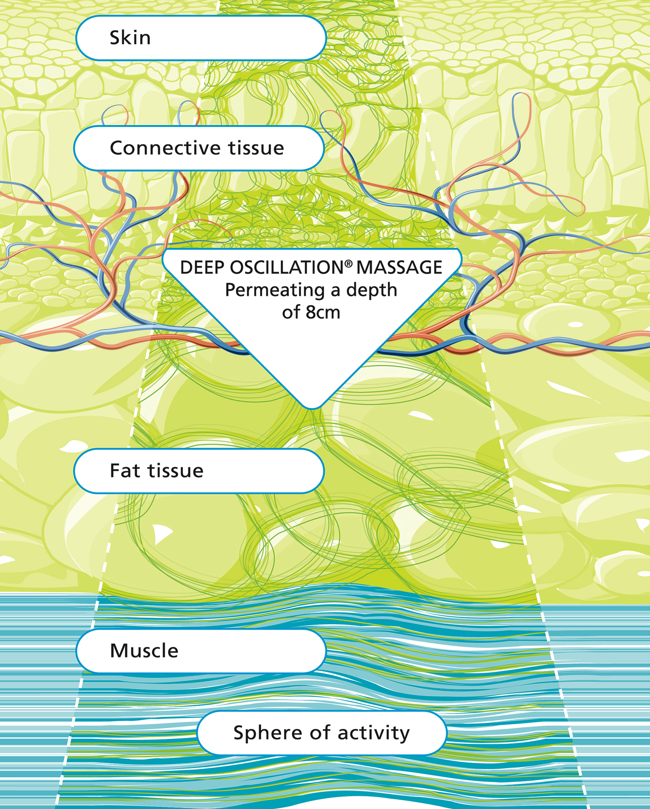

Clinically proven effects
- Strong pain-alleviating potential. This applies to acute traumatic as well as to chronic pain conditions
- Anti-inflammatory effect
- Prevention and reduction of secondary and primary lymphoedema
- Prevention of fibrotic remodelling processes, reduction of fibrosis
- Muscle relaxation, promotion of physical activity, mobilisation
- Support of wound healing processes
- Normalisation of haemodynamic parameters of the skin, correction of aesthetic-neurotic problems and influence on biological ageing through preventive effects on premature ageing
Fields of Application:

Acute Trauma & Chronic Conditions, softening scar tissue
Wound healing, Diabetic Foot, Burns and Ulcers
Musculoskeletal disorders
Primary and Secondary Lymphoedema, Chronic Oedema
Lipoedema and Lipo-Lymphoedema,
Training Aftercare & Performance Stabilisation in Sport, Damage from Overstraining
Pre and Day One Post Operative: Orthopedic, General & Aesthetic Surgery
Neuro Rehabilitation
Pain Syndromes (FMS, Sudeck's Dystrophy etc.)
Common conditions: Arthritis, Back Pain, Tennis & Golfers Elbow, Whiplash

….Aesthetic & Post Partum including:

Anti-Ageing of face and neck, eye bags, dark circles
Cellulite, Grade 1 & 2
Post Classic and Vaser Liposuction
Breast Feeding Problems & Caesarian Healing

Studies/Books/Other Publications/Interviews
Studies

Aliyev R., Mikus E.W.S., Reinhold J.G. (2008): Hochsignifikante Therapieerfolge mit DEEP OSCILLATION® in der orthopädischen Rehabilitation. Orthopädische Praxis 44, 448-453.
English title: Significant Therapy Improvements with DEEP OSCILLATION® in Orthopaedic In-patient Rehabilitation.

Aliyev R.M., Reinhold J., Seidov I.I., Mikus E.W.J. (2009): Ergebnisse mit DEEP OSCILLATION® bei Verletzungen des oberen Sprunggelenkes. Orthopädische Praxis 45, 502-506.
English title: Results with DEEP OSCILLATION® for Injuries to the Upper Ankle Joint.

Aliyev R. (2009): Klinische Wirksamkeit des Therapieverfahrens Tiefenoszillation bei Sportverletzungen. Sportverl Sportschaden 23, 1-4.
English title: Clinical effects of the therapy method deep oscillation in treatment of sports injuries.

Aliyev R.M. (2012): Better Functional Results of Conservative Treatment in Fresh Lateral Ligament Injuries of the Ankle with Additional Deep Oscillation. Phys Med Rehab Kuror 22, 9–15.

Andreev A. (2015): Deep oscillation, kinesiotaping and exercises in amateur football players after ACL reconstruction. XXIV International Conference on Sports Rehabilitation and Traumatology. London, PB06.

Boisnic S., Branchet M.C. (2013): Anti-inflammatory and draining effect of the Deep Oscillation(R) device tested clinically and on a model of human skin maintained in survival condition. Eur J Dermatol 23(1), 59-63.

Bolaños F. (2009): Efectividad de las oscilaciones profundas Hivamat personal en la patalogía artrósica de rodilla: Estudio de caso en adultos mayores. Universidad Santa Paula.

Fistetto G., Iannitti T., Capone S., Torricelli F., Palmieri B. (2011): Deep Oscillation®: esperienze terapeutico-riabilitative con un nuovo innovative strumento ad azione elettrostatica. Minerva Med 102(4), 277-88.
English title: Deep Oscillation: therapeutic-rehabilitative experiences with a new electrostatic device.

Gao Y.-C., Peng C.-C., Peng R.Y. (2015): A long term chronic fibrotic adhesion of elbow muscles alleviated by applying hivamat 200 deep oscillation therapy. International Journal of Multidisciplinary Research and Development 2(1), 286-289.

Gasbarro V., Bartoletti R., Tsolaki E., Sileno S., Agnati M., Coen M., Conti M., Bertaccini C. (2006): Ruolo dell´oscillazione profonda (Hivamat® 200) nel trattamento fisico del linfedema degli arti. La medicina estetica 30(4), 473-478.
English title: The role of deep oscillation therapy (Hivamat® 200) in the physical treatment of the lymphoedema of the limbs.

Gasbarro V., Bartoletti R., Tsolaki E., Sileno S., Agnati M., Conti M., Bertaccini C. (2006): Role of Hivamat® (deep oscillation) in the treatment for the lymphedema of the limbs. EJLRP 16(48), 13-15.

Han M.A., Ivanova D.A., Ljan N.A., Lukina O.F. (2012): Application of the pulse low-frequency electrostatic field at bronchial asthma of children. Russian Journal of Rehabilitation Medicine 1, 21-32.

Hernández Tápanes S., Suárez A., Bravo Acosta T., Wilson Rojas R., Fernández Prieto B., Cabrera Morales M. (2009): Valor de la terapia con oscilaciones profundas en la cicatrización de las quemaduras AB. Rev Cub MFR 2(1) [revista en la Internet]. Cited 05.02.2016; available from www.sld.cu/verpost.php?pagina=1&blog=http://articulos.sld.cu/revrehabilitacion/&post_id=171&c=3734&tipo=2&idblog=110&p=1&n=dee.
English title: Value of deep oscillation therapy in the healing of AB burns.

Hinman M.R., Lundy R., Perry E., Robbins K., Viertel L. (2013): Comparative Effect of Ultrasound and DEEP OSCILLATION® on the Extensibility of Hamstring Muscles. Journal of Athletics Medicine 1(1), 45-55.

Horn A., Mischler B. (2015): Kurzzeitwirkung von Tiefenoszillation auf die Fein- und Grobmotorik bei Multiple-Sklerose-Patienten und -Patientinnen mit Funktionseinschränkungen der Hand: Eine Einzelfallstudie. Berner Fachhochschule Fachbereich Gesundheit.

Jahr S., Schoppe B., Reisshauer A. (2008): Effect of treatment with low-intensity and extremely low-frequency electrostatic fields (Deep Oscillation) on breast tissue and pain in patients with secondary breast lymphoedema. J Rehabil Med 40(8), 645-50.

Johanning-Csik F. (1994): Behandlung postpartaler Brustschmerzen und -spannungen mit dem Intensivierungssystem Hivamat. Medical dissertation. Erlangen - Nürnberg.

Kashilska Y., Petkov A., Micheva P., Batashki A., Batashk Z. (2015): Improving the quality of life through effects of treatment with low intensity extremely low-frequency electrostatic field with sound - DEEP OSCILLATION® in patients with breast cancer with secondary lymphoedema to patients treated with standard lymph equipment. Medicine V(1), 381-387. Précis coming in English in PCNR July 2016

Korkina L., Reinhold J., Rota L., Primavera G., Raskovic D. (2007): Treatment of Gynoid Lipodystrophy (Cellulite) with Deep Oscillation®: A Pilot Clinical Study. 29th Annual Meeting of The Bioelectromagnetics Society. Kanazawa, 2.

Kraft K., Kanter S., Janik, H. (2013): Safety and effectiveness of vibration massage by deep oscillations: a prospective observational study. Evid Based Complement Alternat Med.;2013:679248. doi: 10.1155/2013/679248. Epub 2013 Oct 3.

Mikhalchik E., Titkova S., Anurov M., Suprun M., Ivanova A., Trakhtman I., Reinhold J. (2005): Effects on blood parameters of Deep Oscillation. 1st International Conference on Skin and Environment. Moscow-St. Petersburg, 59.

Mikhalchik E., Titkova S., Anurov M., Suprun M., Ivanova A., Trakhtman I., Reinhold J. (2005): Wound Healing Effects of Deep Oscillation. 1st International Conference on Skin and Environment. Moscow- St. Petersburg, 71.

O’Brien CP and Watson A (2016): Deep Oscillation® Therapy in the Treatment of Lateral Epicondylalgia: A Pilot Randomized Control Trial, J Sports Med Doping Stud 2016, 6:3
Nourollahi S., Mondry T.E., Herbst K.L. (2013): Bucher’s Broom and Selenium Improve Lipedema: A Retrospective Case Study. Altern Integ Med 2(4), 119.

Reinhold J., Deeva I., Korkina L., Schaper K., Krummenauer F. (2014): Randomisierte Pilotstudie zur Quantifizierung des patientenseitigen Nutzens der Beeinflussung primärer Wundheilungsprozesse durch Tiefenoszillation. Z Orthop Unfall 152(3), 260-264.
English title: Randomised Pilot Study for Quantification of Benefit from the Patient's Point of View of Deep Oscillation Treatment in Primary Wound Healing.

Sänger H.-F. (1995): Der Einfluß von HIVAMAT® 200 (histologisch-variable Technik) auf die Entstehung der radiogenen Fibrose bei brusterhaltend therapierten Patientinnen mit Mammakarzinom. Medical dissertation, Erlangen - Nürnberg.

Scannavini P., Bitocchi M., Rossi M., Girvasi L. (2012): Lesioni muscolari da sport: percorsi di riatletizzazione. Scienze motorie, ortopediche, riabilitative 60, 31-35.
English title: Sports muscle injuries: athletic recovery paths.

Schönfelder G., Berg D. (1991): Nebenwirkungen nach brusterhaltender Therapie des Mammakarzinoms. Erste Ergebnisse mit Hivamat. gynäkol. prax. 15, 109-122.
English title: Side effects following conservative therapy for a carcinoma of the breast. Initial results with Hivamat.

Sporbeck B., Mathiske-Schmidt K., Jahr S., Huscher D., Becker M., Riemekasten G., Taufmann I., Burmester G.R., Pögel S., Reisshauer A. (2011): Effect of biofeedback and DEEP OSCILLATION® on Raynaud's phenomenon secondary to systemic sclerosis: results of a controlled prospective randomized clinical trial. Rheumatol Int 32(5), 1469-73.

Isobel Teo, Anna Coulborn, DA Munnoch 2016: "Use of the HIVAMAT® 200 with manual lymphatic drainage in the management of lower limb lymphoedema and lipoedema. Journal of Lymphoedema June 2016, Volume 11 Issue 1

Theys S., Deltombe T., Legrand C., Hanson P. (2008): Manual Drainage with or without DEEP OSCILLATION® in Lower Extremity Oedema. J Rehabil Med Suppl 47, 62.

Trybulski R. (2008): Wykorzystanie hivamat 200 w leczeniu ran. Rehabilitacja w Praktyce 1, 28-33.
English title: Using Deep Oscillation system in the treatment of wounds.

Trybulski R. (2016): Metoda DEEP OSCILLATION w leczeniu zespou stopy cukrzycowej. PRAKTYCZNA fizjoterapia & rehabilitacja 68, 22-29.
English title: DEEP OSCILLATION method in treatment of diabetic foot syndrome.

Yashkov A.V., Gazdieva E.M., Badyanova I.S. (2007): Efficacy of intermittent low-frequency electrostatic field in the sanatorium-based complex treatment of patients with chronic obstructive pulmonary disease. Kurortniye Vedmosti 3(42), 62-63.

Zehtindjieva M.G., Ioshinov B.R., Andonov D.R., Ilkov V.S., Bayraktarova A. (2013): Deep Oscillation – A Modern Additional Physical Modality For Analgesia In Patients With Back Pain. PRAEMEDICUS 29, 85-90.

Other Publications

Anonymous (2010): Lymphödem nach Therapie bei Brustkrebs. Nutzen elektrostatischer Felder als Zusatzbehandlung zur manuellen Lymphdrainage. natur-heilkunde journal 10, 34-35.

Brenke R., Siems W. (1996): Adjuvante Therapie beim Lymphödem. Lymphol 20, 25-29.
English translation: Accompanying Therapy in Lymphoedema

Fickling M., (2016): DEEP OSCILLATION® – A Welcome Tool To The Box. Massage World Issue 93 2016

Fickling M. (2015): Eight Years On - An MLD DLT Practitioners & Lymphoedema Therapist Review of {{do}} ({{h2}} Therapy. MLD UK "The Journal" Winter Issue

Fickling M. (2014): "It's about ability, not disabilities - DEEP OSCILLATION® For Pain Management" Empower Magazine Issue 2.,

Fickling M., Cruickshank MacNicol E. (2014): "FAQ Regarding DEEP OSCILLATION Self Management Post Amputation" Empower Magazine Issue 6. Page 51

Fickling M. (2014): "DEEP OSCILLATION® making electrostatic waves in UK Healthcare" Choice Health and Wellbeing Magazine, Autumn Issue

Fickling M. (2014): "DEEP OSCILLATION® Electrostatic Massage Therapy - Helping Health Care Professionals improve care pathways for lymphoedema, lipoedema, lipo-lymphoedema sufferers" Primary Care Nursing Review (PCNR), Issue 1. Product Focus and Reviews

Fickling M. (2013): "A review of how a gentle, non-invasive, electrostatic massage therapy (applied through gloved hands) has changed the way in which therapists work, achieving very effective results for their clients" Choice Health & Wellbeing Magazine feature DEEP OSCILLATION® in Sept/Oct Issue.

Fickling M. (2010): "DEEP OSCILLATION® Deep tissue massage therapy - a major breakthrough for therapists" Choice Health and Wellbeing Magazine, April/May Issue.

Fickling M. (2010): "DEEP OSCILLATION® helping change the lives of Lymphoedema Sufferers" Choice Health and Wellbeing Magazine, Dec/Jan Issue.

Fickling M. (2009): {{do}} The Therapist, Spring Issue

Youn Hee K. (2009): deep oscillation, perfect body. BELLISSIMA KOREA 8, 110-111.

Kraus R. (2014): Intensivere Lymphdrainage durch Tiefenoszillation. LYMPHE & Gesundheit 2, 6-8.

Liebl M.E., Willems S., Hoffmann S., Schwedtke C., Meuche S., Hermann K.G., Reißhauer A. (2012): Fachübergreifende Frührehabilitation an der Charité. Interdisziplinäre und multiprofessionelle Maximalversorgung. Z f Physiotherapeuten 64(6) [special supplement].

Newbold T. (2010): "{{do}} - A Therapist Review" Choice Health and Wellbeing Magazine. Autumn Issue

Onose G., Daia-Chendreanu C., Haras M., Popescu C., Andone I., Mirea A., Neculai M. (2009): DEEP OSCILLATION® Our Experience Concerning the Use of Deep Oscillation in the Therapy of Osteoarthritis. The Proceedings from the National Conference of Neurosurgery and Neurorehabilitation. Mamaia, 2nd edition.

Reisshauer A., Pögel S. (2010): Therapie des sekundären Armlymphödems bei Mammakarzinom. gynäkol. prax. 34, 489–499.

Schingale F.-J. (2006): Kopf-, Brust- und Genitallymphödem - eine besondere Herausforderung für den Lymphtherapeuten. vasomed 1, 30-31.

Soroczyn J. (2008): Magic Hands - {{do}} Massage World - The Massage and Body Therapists Magazine, April/May, 9-10, 16.

Talbot C. (2011): Lymphoedema Support Network periodical 'Lymphline', Spring Issue, {{do}} for lymphoedema

Watson A. (2010): Annual PGA Magazine, "New Treatment Helping You Out Of The Rough"

Watson A. (2010): The Senior Times, Ireland, "Thumbs Up For Pain Free Gardening"

Watson A. (2010): Choice Health & Wellbeing Magazine. "Highlight of a tough year... DEEP OSCILLATION® came to Ireland"

Wehner H., Wehner W. (2006): Physiologische Zusatzhilfe gegen Lymphstau, Ödem und Schmerzen. HIVAMAT® 200: Aus dem Klinik- und Praxisalltag nicht mehr wegzudenken. Die Naturheilkunde 4, 43-45.

Wehner H., Wehner W. (2005): HIVAMAT® 200 - Erfahrungen mit der apparativen Lymphdrainage und Tiefenmassage bei onkologischem Krankengut in einer Spezialklinik für integrative Medizin. Die Naturheilkunde 6, 41-44.

Weiss A. (2015): Intensivere Lymphdrainage durch Tiefenoszillation (Deep Oscillation®). Reflexe 6, 19-21.

Yerrissian S. (2008): New device on block. MLD UK 14(2), 5.

Yerrissian S. (2008): Deep Oscillation Therapy and the case of a swollen eyelid. MASSAGE WORLD. The Massage and Body Therapists Magazine Aug/Sept.

Books

Bossert F-P., Vogedes K. (2014): Deep Oscillation. In: Bossert F-P., Vogedes K. (Ed.): Elektrotherapie, Licht- und Strahlentherapie. 3. Aufl., Elsevier GmbH, 139-146.

Brenke R., Freund R., Strößenreuther R.H.K. (2010): Adjuvante Physikalische Therapie beim Lymphödem sowie bei ausgewählten Begleiterkrankungen am Bewegungsapparat. In: Földi M., Földi E. (Ed.): Lehrbuch Lymphologie. 7. Aufl., Elsevier GmbH, 508.

Hernández Tápanes, S. (2012), Terapia con oscilaciones profundas. Experiencias en cervicalgias, lumbalgias y epiconylitis., EdiReh-Latina.

Reißhauer A., Auler S., Bieringer S., Jahr S. (2009): Physikalische Entstauungstherapie. In: Reißhauer A., Auler S., Bieringer S., Jahr S. (Ed.): Kompendium der lymphologischen Kompressionsversorgung. Bundesfachsschule für Orthopädie-Technik, 42-57.

Seidl H. (2006): Das Verfahren HIVAMAT im Rahmen der Entstauungstherapie. In: Bringezu G., Schreiner O. (Ed.): Lehrbuch der Entstauungstherapie. 2. Aufl., Springer Medizinverlag, 245-250.

Lipiska A., Opuchlik A.(2014): Fizykoterapia w onkologii. In: liwiski Z., Siero A. (Ed.): Wielka Fizjoterapia. Elsevier GmbH, 289-294.
English title: Physical Therapy in Oncology.

Radio Interviews

Griffith W. (2010) PT TALKER with Jeff Worrell. Interview William Griffith about DEEP OSCILLATION®

Talbot C. (2010) Holistic Hour "The Lymphatic System and Lymphoedema, how {{do}} has made a remarkable difference to patient care"

EQUINE

School of Animal, Rural and Environmental Sciences, Nottingham Trent University, Brackenhurst, Southwell, Nottingham, UK, NG25 0QF Email: lyn.hopegood@ntu.ac.uk Tel: 01636 817014 Lyn Hopegood : Physiological Effects of Massage and DEEP OSCILLATION® on the Horse See Poster Presentation

