Bird Dog (Remedial)

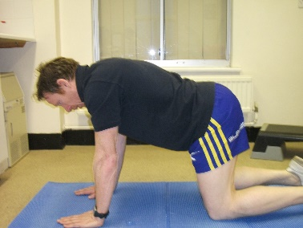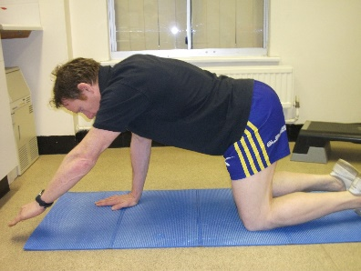
Description:
- Start in 4 point kneel position.
- BRACE abdominals
- Spine neutral
- Keep shoulder blades under control
- Keep neck in line with head in neutral position
- Arm slide forward under control
- Pelvis and spine should remain in neutral throughout, keep all 4 points of table in line
X10 each arm, hold 5 secs at end of range

Box press up
Description:
- Keep weight over wrists
- BRACE abdominals
- Spine neutral
- Keep shoulder blades under control
- Keep neck in line with head in neutral position
- Arm slide forward under control
- Pelvis and spine should remain in neutral throughout, keep all 4 points of table in line
- Bend arms to touch nose 6” in front of line joining ends of fingers, straighten arms to return
X10

