WILLOW HOUSE PHYSIOTHERAPY & PERSONAL TRAINING LTD
BASIC PILATES EXERCISES

PELVIS NEUTRAL

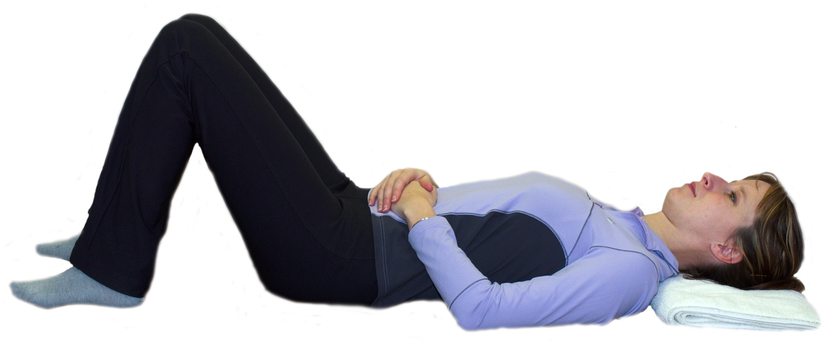
- Place heels of your hands on the bony prominences at the front of the pelvis, and join the fingers to overlap over the pubis area.
- Rock the pelvis backwards and forwards to the extremes of range and find the middle of the range between the two extremes.
- Your hands should be level, so if a pint of water was placed on the abdomen it would not topple or spill!

TRANSVERSUS ABDOMINUS ACTIVATION

- Find pelvis neutral position.
- Place hands on lower abdomen
- Inhale
- Exhale and gently draw in the lower abdomen away from your hands down towards the floor.
- Inhale to relax and exhale to repeat the process again.
- Repeat x10

LEG SLIDE

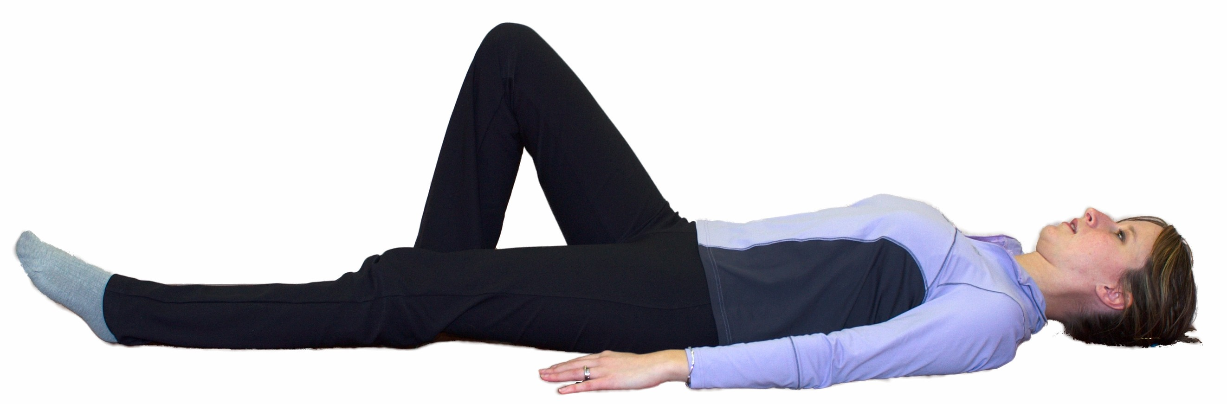
- Crook lying, in pelvis neutral
- Inhale to set Transversus Abdominus
- Exhale to slide one foot out along the floor until straight.
- Inhale to stay
- Exhale to slide the foot back up to starting position
- Do not let the pelvis rotate or Transversus Abdominus fatigue throughout the exercise

SINGLE LEG PICK UP

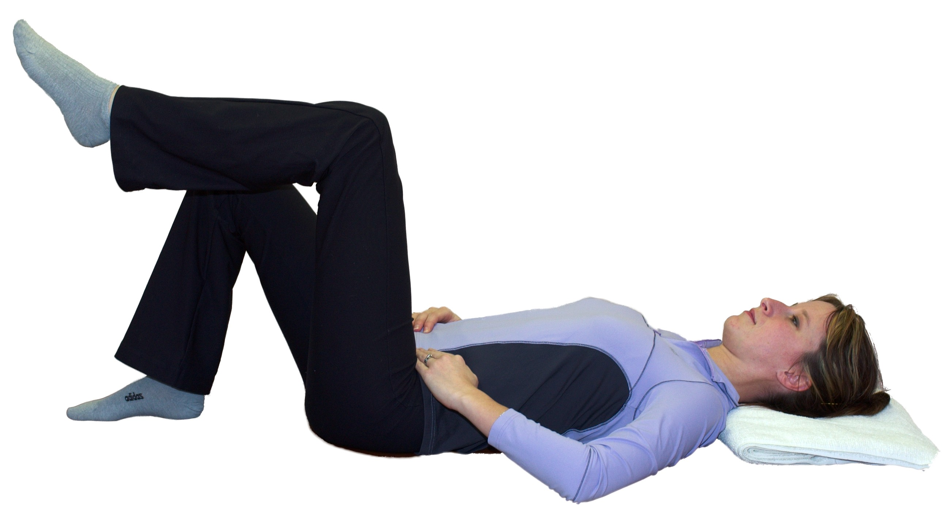
- Crook lying, in pelvis neutral
- Inhale to set Transversus Abdominus
- Exhale to float one knee up over the hip to 90 degrees hip flexion
- Inhale to stay
- Exhale to float the leg back to starting position
- Do not let the pelvis rotate or Transversus Abdominus fatigue throughout the exercise

HIP TWIST LEVEL 1 (BENT KNEE FALL OUT)

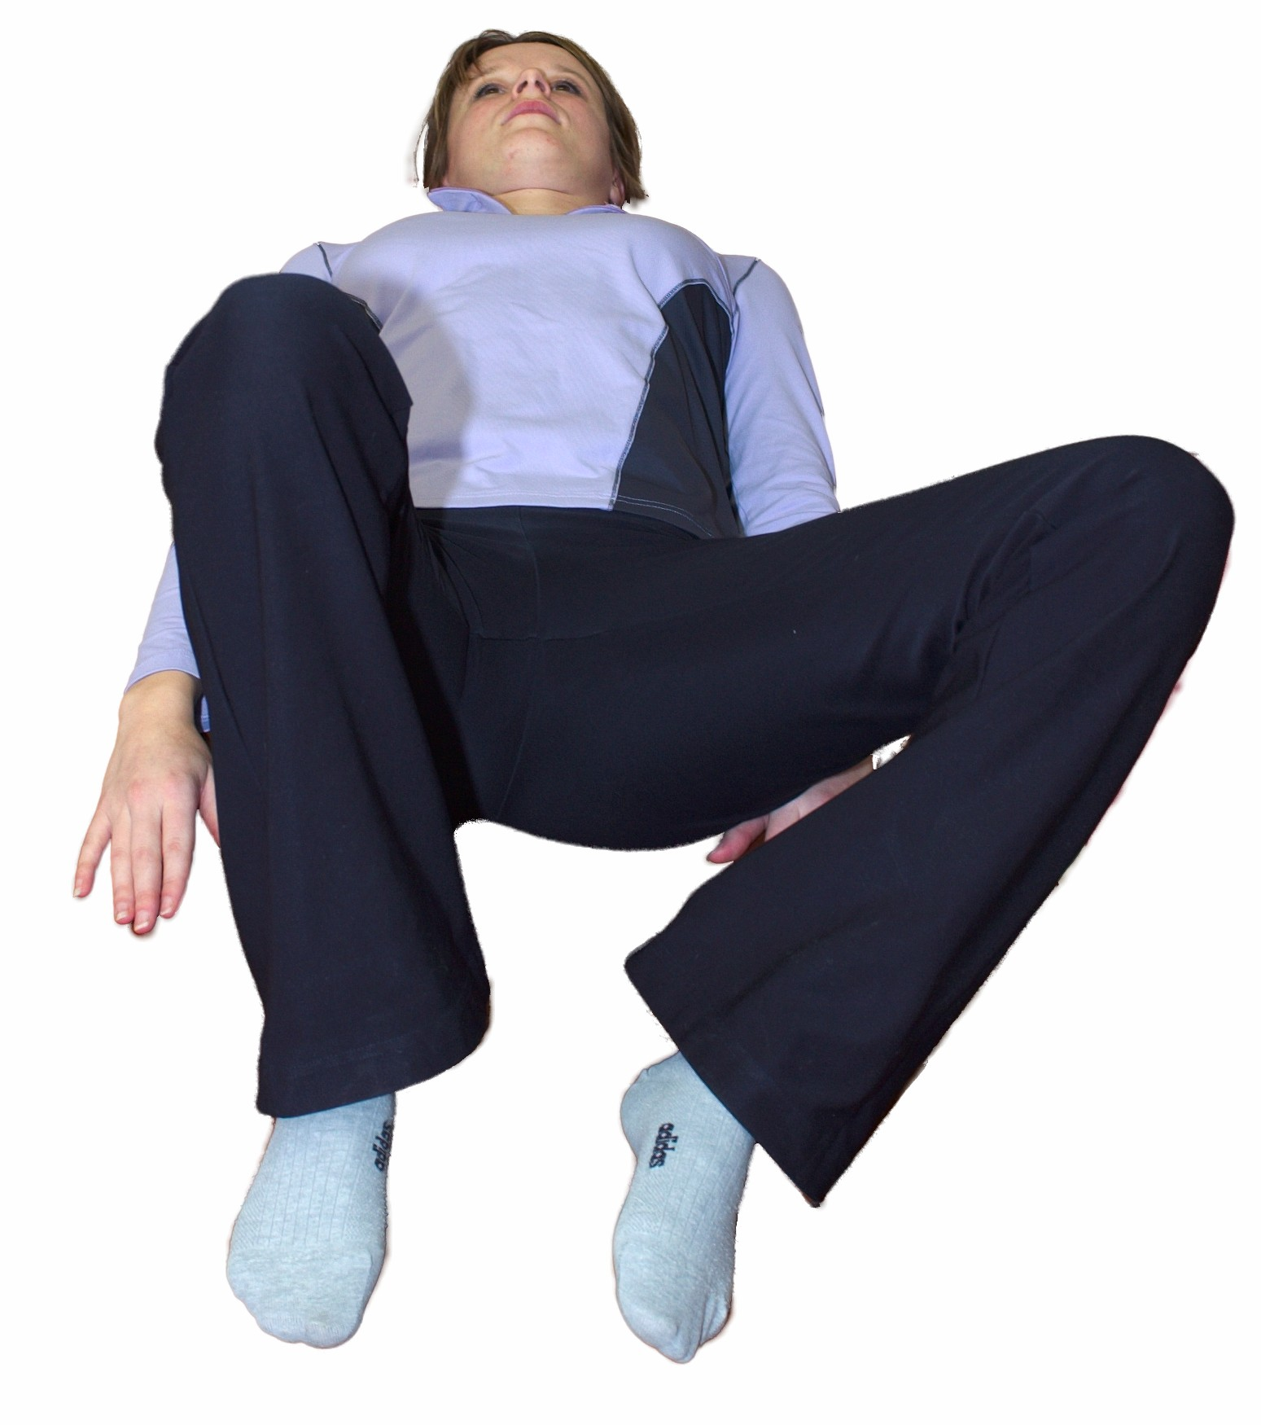
- Crook lying in pelvis neutral
- Inhale to set Transversus Abdominus
- Exhale to let one knee drop out to the side away from the midline, maintaining a level pelvis.
- Inhale to control the knee back to the starting position
- Repeat x10 each leg

