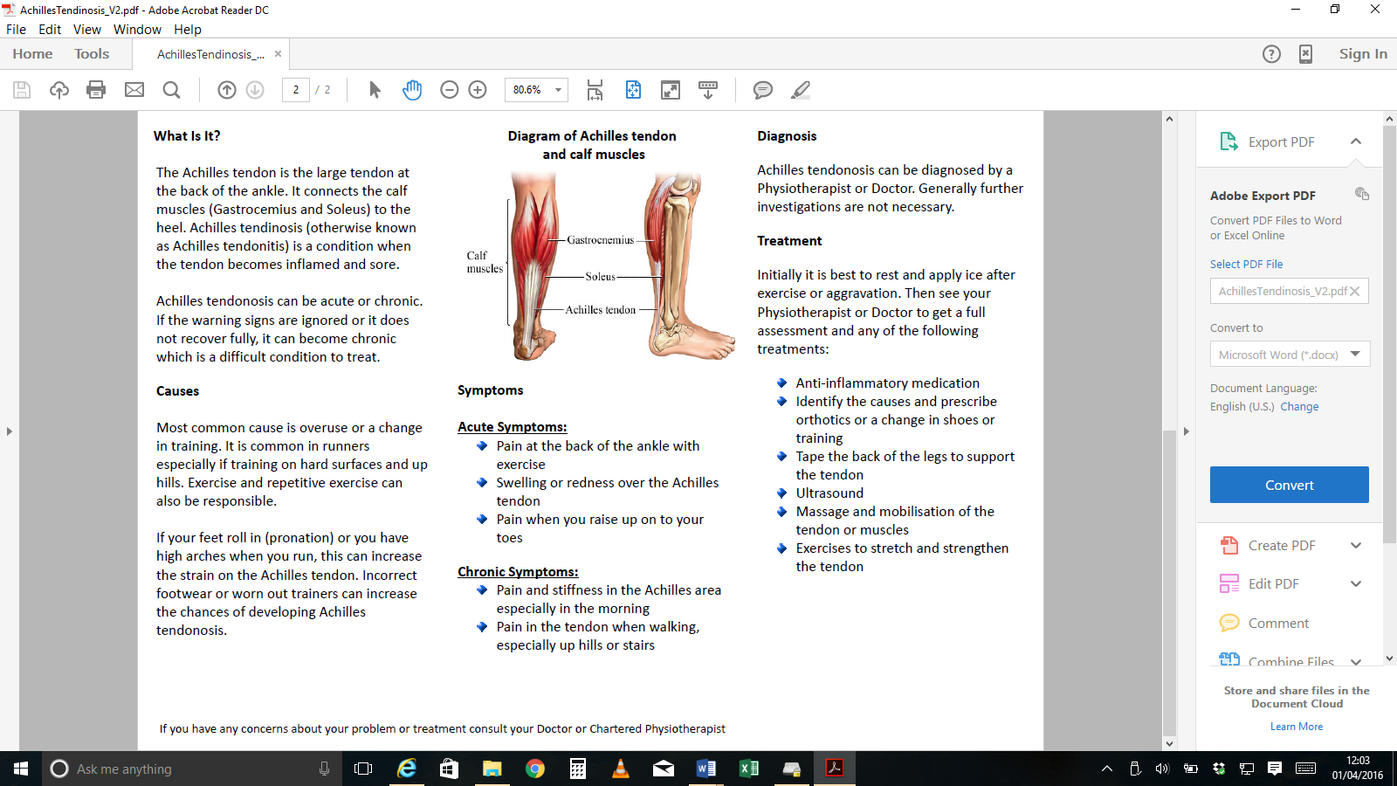

Your Physiotherapist will advise you if correction of your foot posture would be helped with off the shelf orthotics.

Application of Kinesio Tape

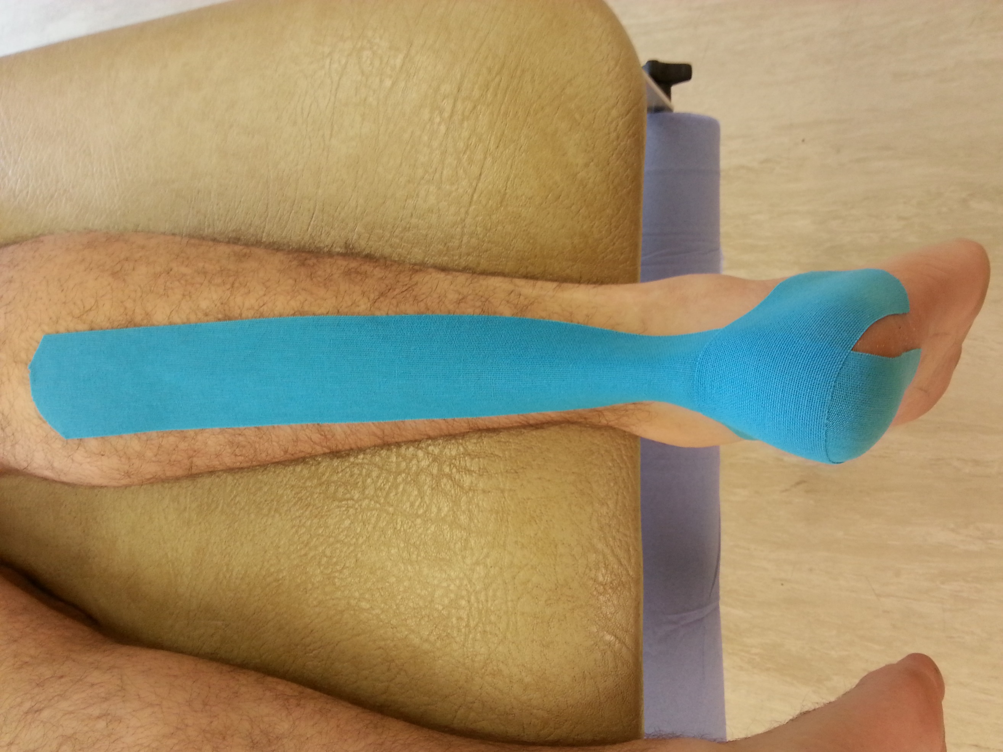

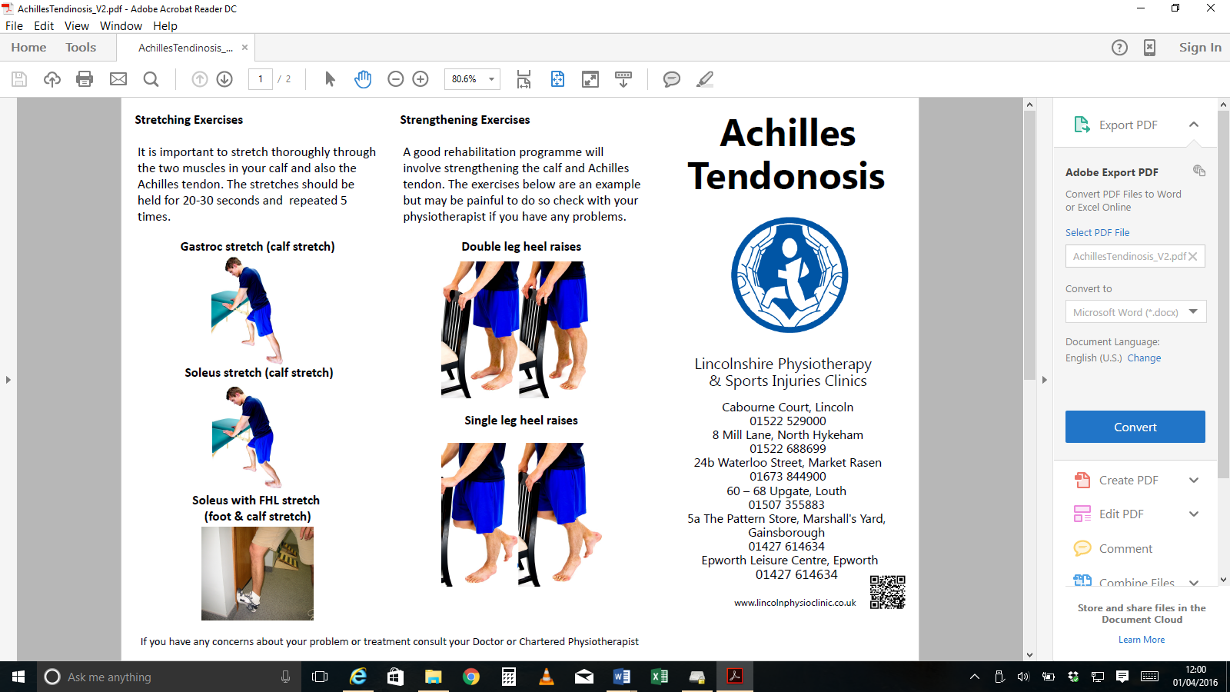

**Calf Stretch**

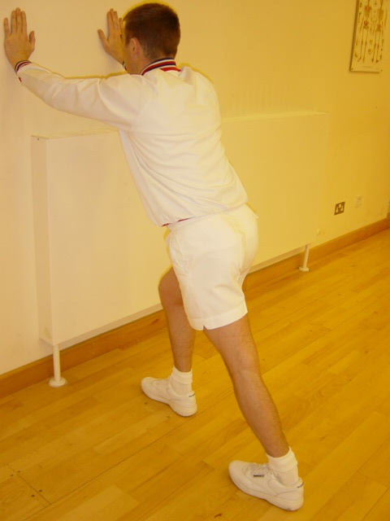

Standing, with the use of a wall. Place the leg to be stretched to the rear and keep both feet facing forwards. Force the hip towards the wall, ensuring the heel remains on the floor. The front leg is used for support.

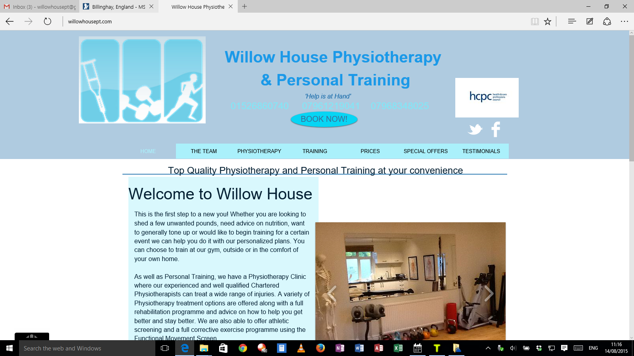

Willow House Physiotherapy & Personal Training

Tattershall Road, Billinghay 01526860740

www.willowhousept.com